AMIS SIG/Conclusion Gilde Machine Learning – Stage One – Functional Labs

May 2018

This workshop is intended to give you a taste of what machine learning can do – what the results of machine learning look like. It does not expect you to write code, dabble in *math* or do anything *technical*. It does introduce you to some concepts, terminology and opportunities.

## Quick Draw

Based on millions of drawings that were labeled by the “artists” – indicating what the drawing tried to depict – Google has created a neural network that can guess the object depicted in new drawings. QuickDraw is a game where a neural net tries to guess what you’re drawing. You do not see the neural network or need to know anything about how it was created. Yet you can easily experience what it can do. Go to <https://experiments.withgoogle.com/ai/quick-draw> and click on *Launch Experiment*.

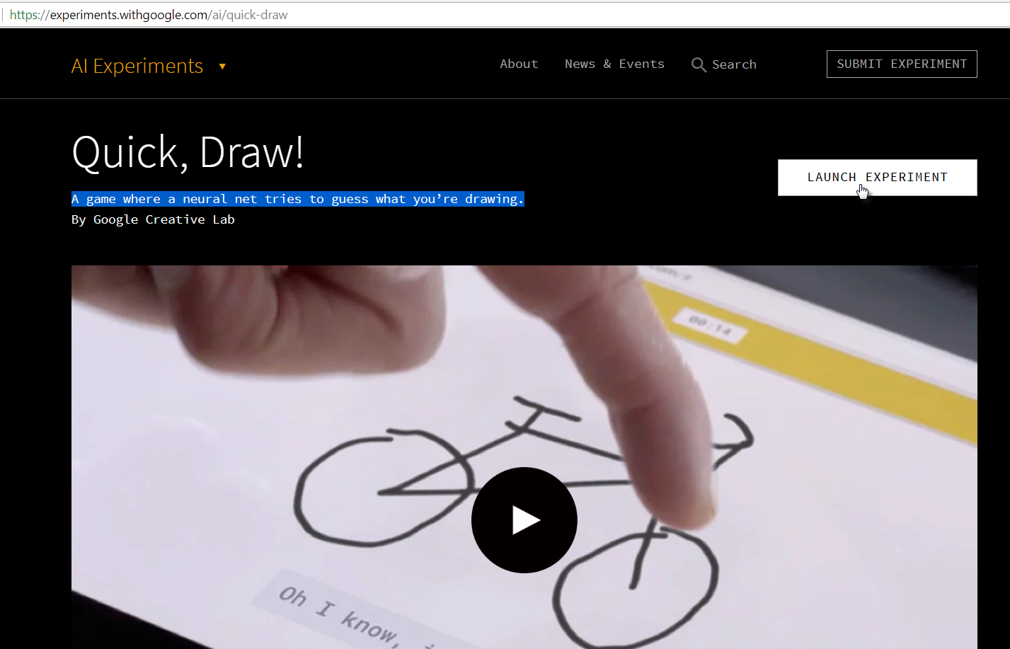

You are taken to a Pictionary-like setting where you are invited to draw an object and the neural network tries to guess what it is you are drawing. If it fails to guess right, it can be blamed on the flaws in the neural network, Or perhaps your drawing skills…

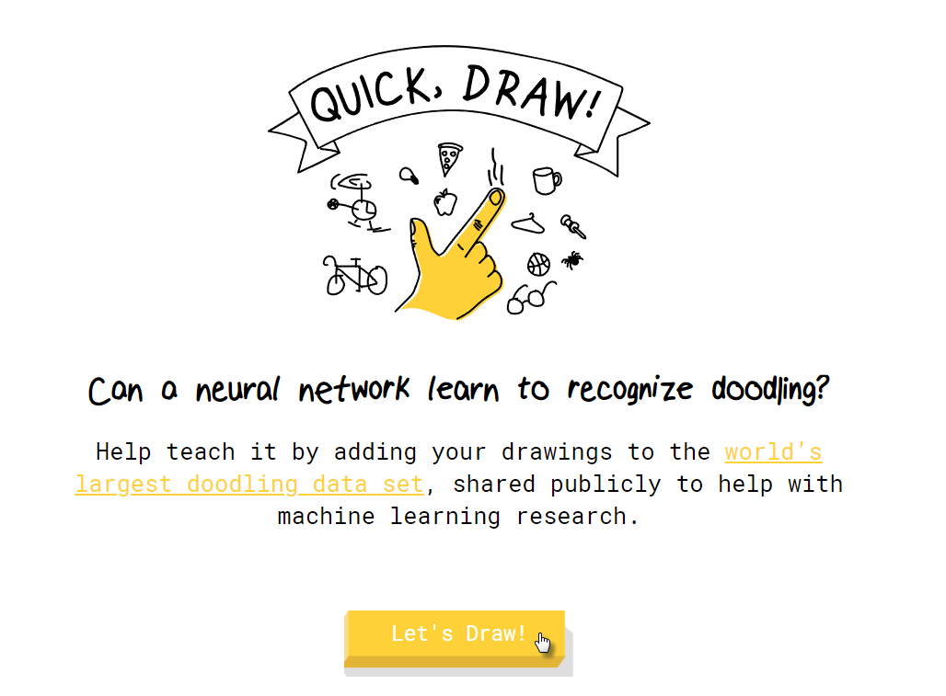

Click on Let’s Draw and get going:

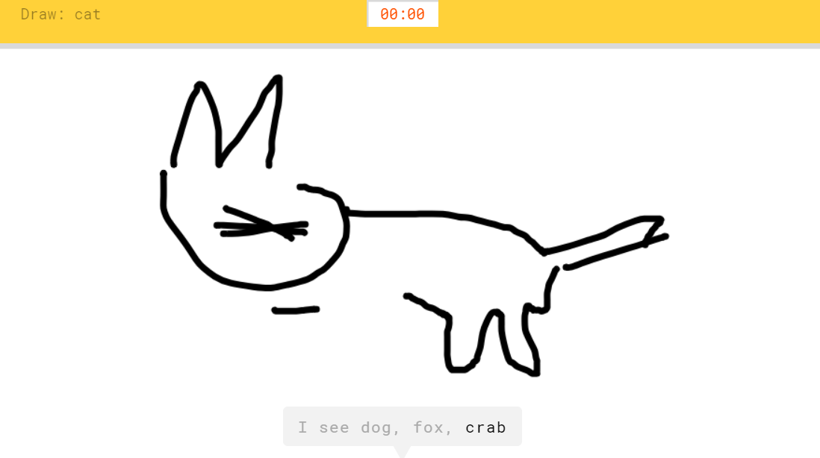

An interesting example of machine learning is found at <https://magenta.tensorflow.org/assets/sketch_rnn_demo/index.html> . Here you see a demonstration of how the machine can work with the human actor to co-create a picture.

## Speech to Text – powered by Watson

Turning text into speech has been implemented in many different ways. From just producing sounds to speaking naturally in a human like tone of voice – in a selected language and using a *suitable* voice, we have come a long way.

To listen to some interesting results in this area, check out the Watson powered service, offered by IBM at <https://text-to-speech-demo.ng.bluemix.net/> .

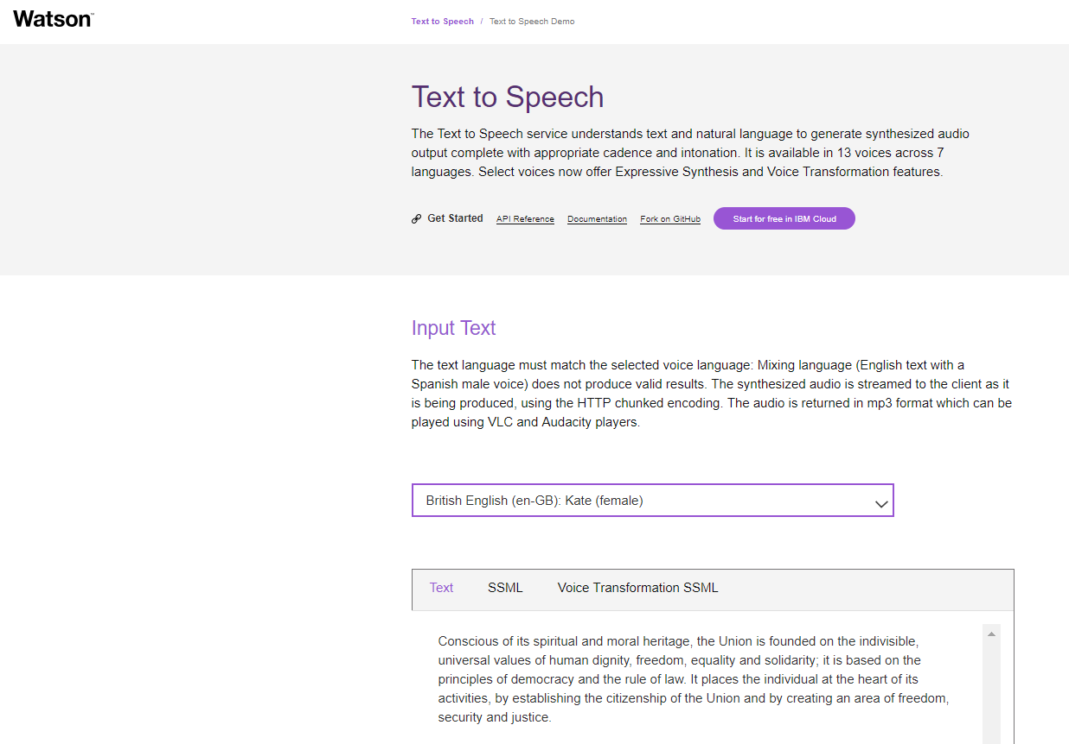

Note: speech to text services like this one can simply be invoked through an REST API call and can therefore be implemented in any application we develop for our customers.

## Speech to Text

Although Speech to Text is quite a bit harder than the reverse, in this area too the advances have been impressive. Dragon Speech, Siri, Alexa and friends are good examples. For speech to text, many cloud services are available that allow us to submit mp3 or mp4 audio snippets or even live streams and have them turned into text – and translated if we would need that – and returned to us. Embedding programmatic speech to text capabilities into our applications is easy to achieve - and does not require specific knowledge of machine learning techniques. While the speech to text is based on a machine learning model – we get to use the ready-made model instead of creating or refining a model of our own.

Go to <https://azure.microsoft.com/en-us/services/cognitive-services/speech/> to try out a speech to text service – one that you can use in the browser or that you can invoke programmatically.

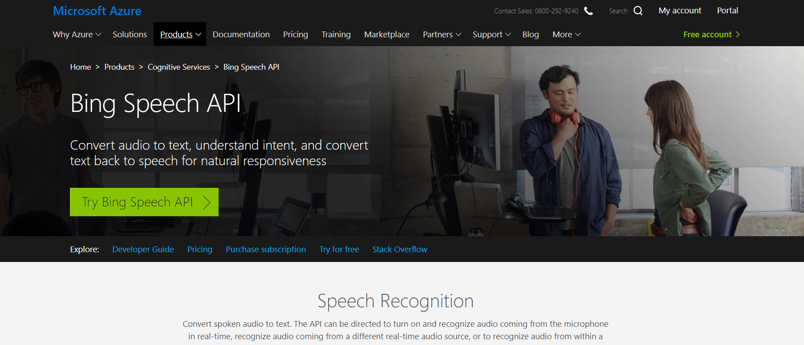

The page contains a big green button Start Recording. When you press the button and enable your microphone, whatever you will say is turned into text. Please specify the target language.

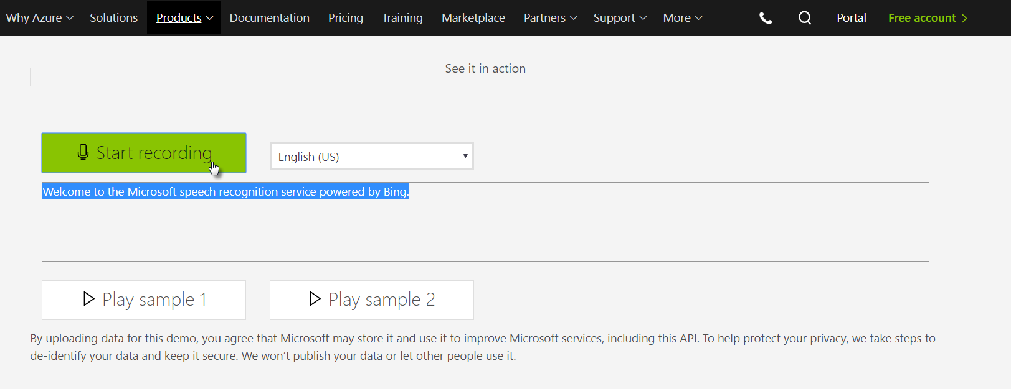

## Text Sentiment analysis

Recognizing the sentiment in a text – whether it is a Tweet, an online review or free text entered in a survey – can be valuable. For quick aggregate analysis or for rapid mediation on social networks. A simple example of sentiment analysis – picking between positive and negative sentiment – is demonstrated in many places, including this one:

<http://text-processing.com/demo/sentiment/>

Powered by open source and based on Python, this demo shows how a text fragment – in one of three languages – is evaluated and judged to be either positive or negative.

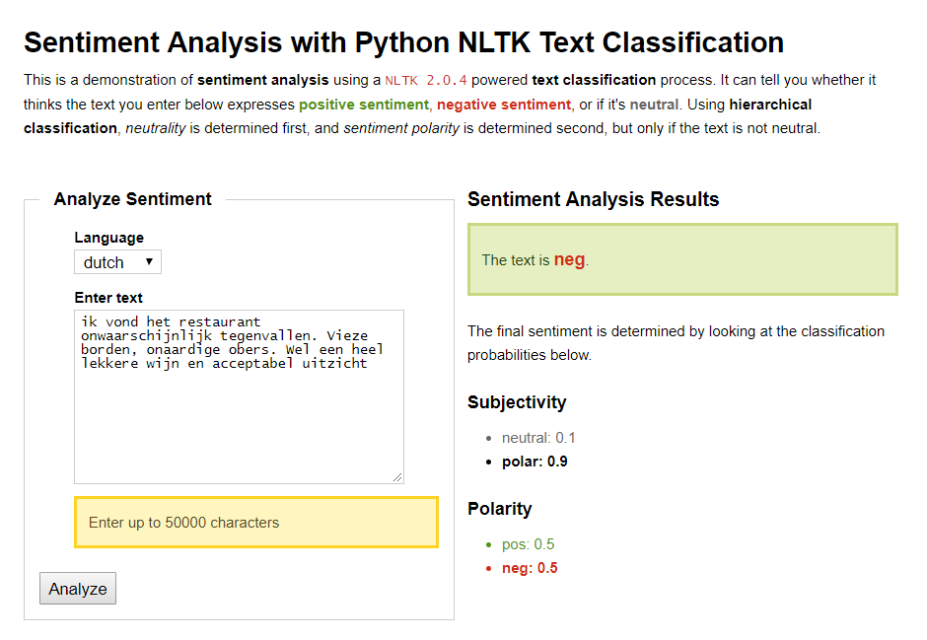

Look at the fairly subtle change in text and its consequence on the overall analysis.

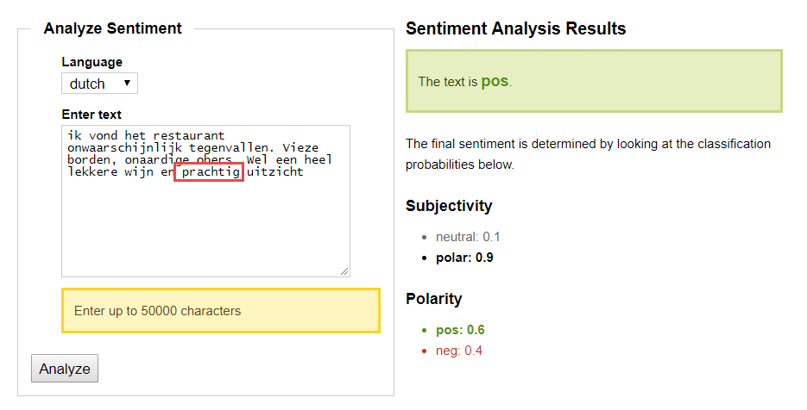

An interesting question is whether or not this change in the review would also sway a human reader’s mind from negative to positive.

Now you try it: enter some text, select the language and press the Analyze button to learn the verdict.

## Categorize and Summarize Text and Suggest Hashtags

Some other interesting demos around text analysis can be found here: <https://developer.aylien.com/text-api-demo?text=&language=en&tab=classify-taxonomy> .

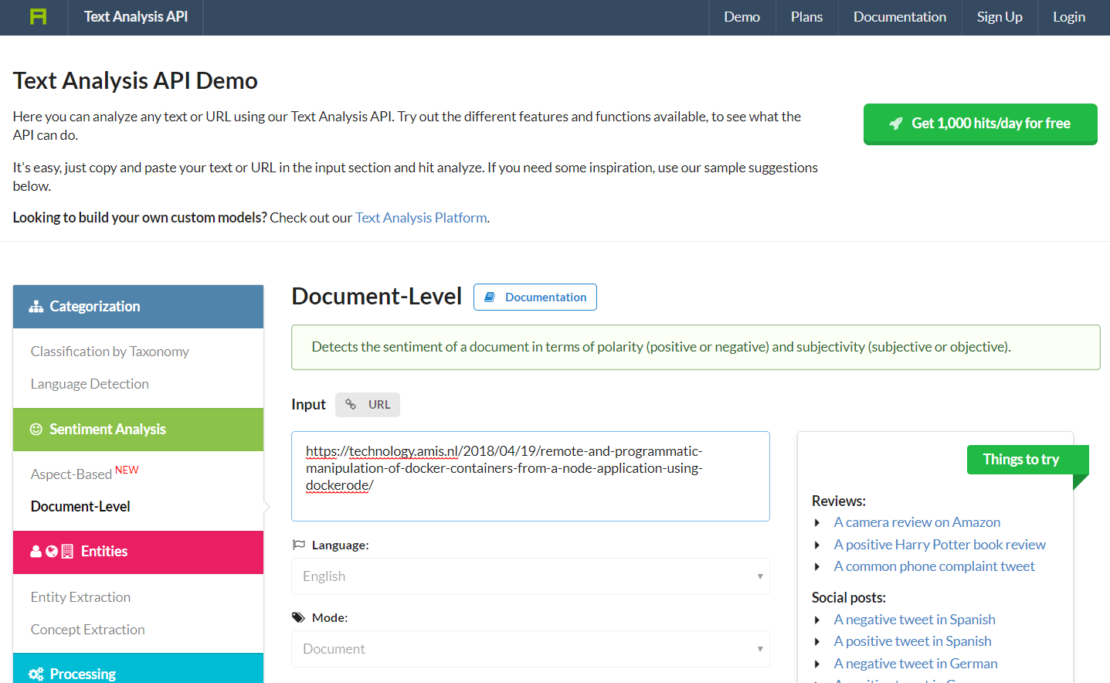

Here you can enter a text or a URL that refers to a page on the internet (for example a Wikipedia topic, a blog article or news story) and have it processed in one of several ways:

* Classify (which are the topics under which this resource can be categorized)
* Summarize (select key sentences that tell the gist of the story)
* Hashtag suggestion
* Language detection
* Sentiment Analysis

Try out some of the available features – all powered by machine learning models that have been created a third party (or more likely: multiple third parties including open source projects and university research results. All these options are exposed through APIs – in other words: all these features can be used in our own applications!

## Digit recognition

Recognizing images can only work if the images represent things we know. And the smaller the set of things we should be able to find in images, the easier the recognition becomes. An example is recognition of digits. A machine learning model for recognizing digits in images only has to choose between ten objects. Not the hardest thing in the world (unless the images are vague of the handwriting is sloppy) and yet very useful.

For a demo of how this works, navigate to <http://scs.ryerson.ca/~aharley/vis/conv/> .

Here you can draw a digit – as vague and sloppy as you like – and have the drawing interpreted by a neural network, trained for recognizing numbers.

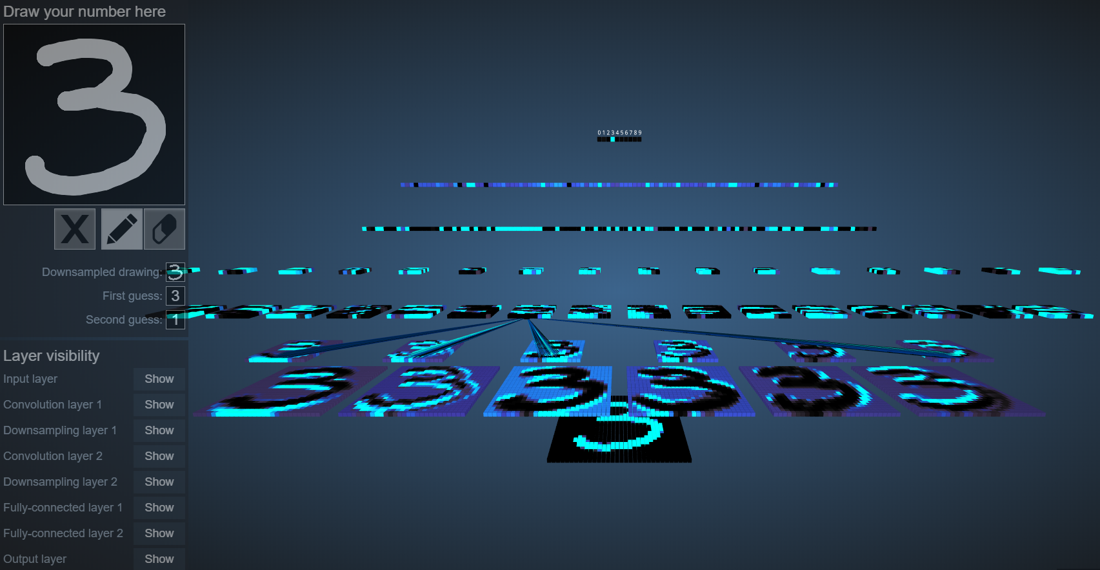

The site also visualizes the internals of the neural network – a pretty picture but way beyond our scope for today.

Another beautiful moving visualization of the neural networks can be seen on this site: <https://www.cybercontrols.org/neuralnetworks> :

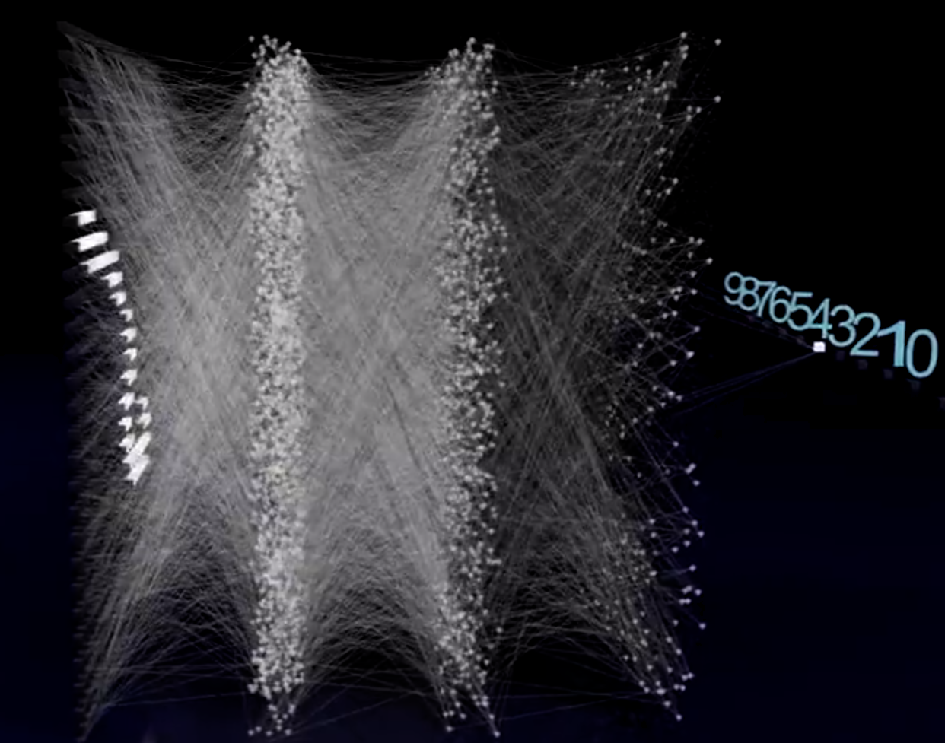

## Image Recognition

Azure is one of several cloud providers that offer a generic image recognition service. Such a service allows us to present an image – gif, jpeg, … - and have the service identify objects in the picture. The service can be tested in a user interface and invoked through an API.

Go to <https://azure.microsoft.com/en-us/services/cognitive-services/computer-vision/> . Scroll down. You can type in or paste a URL to an image. Press Submit and the Azure Image Recognition service – powered by a machine learning model – works its magic and returns a set of labels that it has derived to apply to this image. It will also indicate the confidence it has in its findings.

As you can see: identifying cats can be done with high confidence!

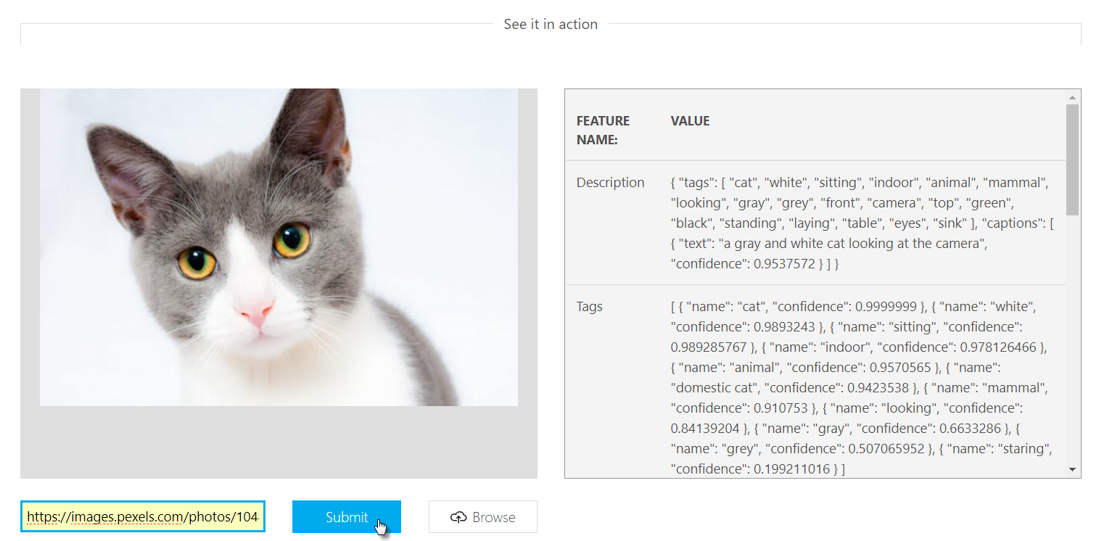

Try to have the service interpret images with multiple objects or with unclear images.

IBMs Watson offers an impressive recognition service of its own, at <https://visual-recognition-demo.ng.bluemix.net/> :

Similar functionality can already be run inside the browser. See for example this demo of image recognition inside an Angular browser application: <https://goodhum.com/machine-learning-with-angular-a-demo/> - and note the not too shabby backend functionality as well as it analyzes a picture of one of our knowledge sessions at AMIS:

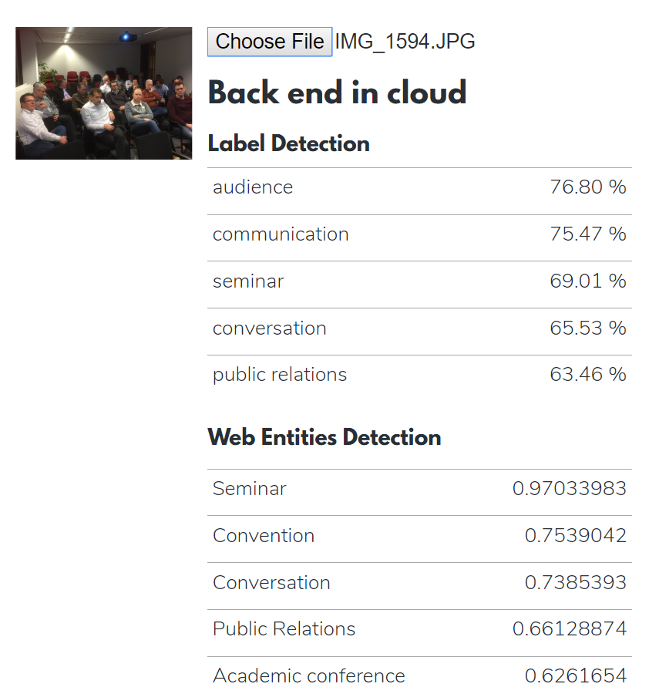

## Teachable Machine

This experiment lets anyone explore how machine learning works, in a fun, hands-on way. You can teach a machine to using your camera, live in the browser – no coding required. You train a neural network locally on your device. The neural network will learn how recognize three different situations – and respond to each of them. It is a very simple example of a very powerful concept. And fun to try.

<https://teachablemachine.withgoogle.com/>

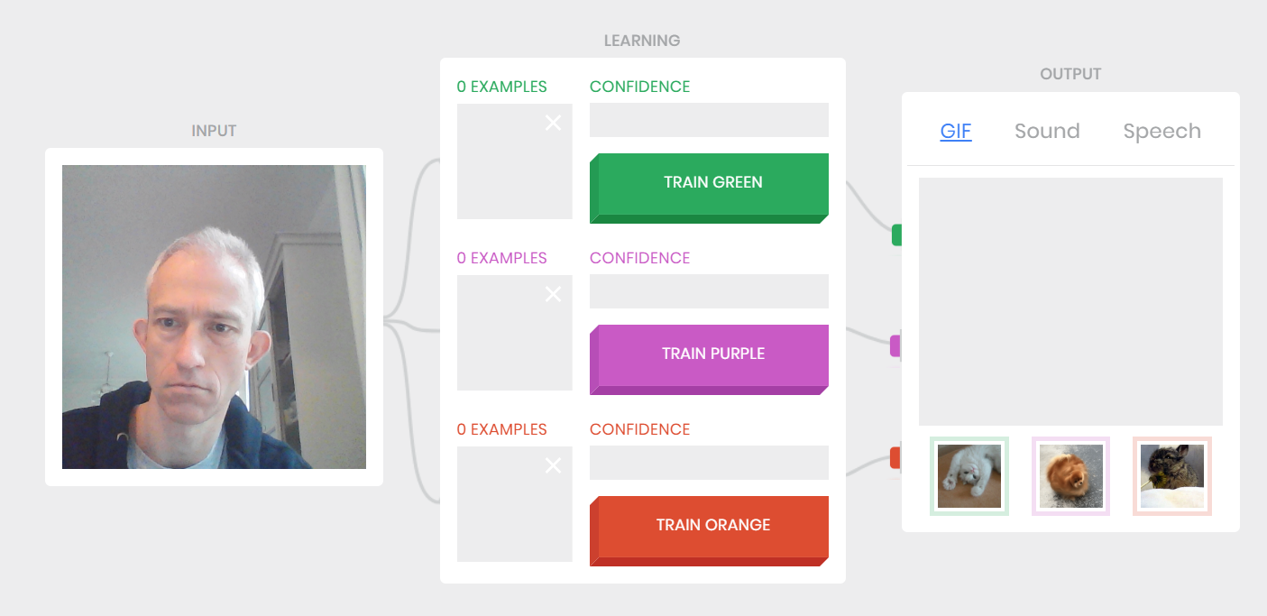

## Decision Tree – Classifying Houses

A very nice, non-technical and visual introduction to machine learning – classification example using the Decision Tree algorithm is shown in this article: <http://www.r2d3.us/visual-intro-to-machine-learning-part-1/> . It tries to determine the location of a house based on (relevant) attributes of the house.

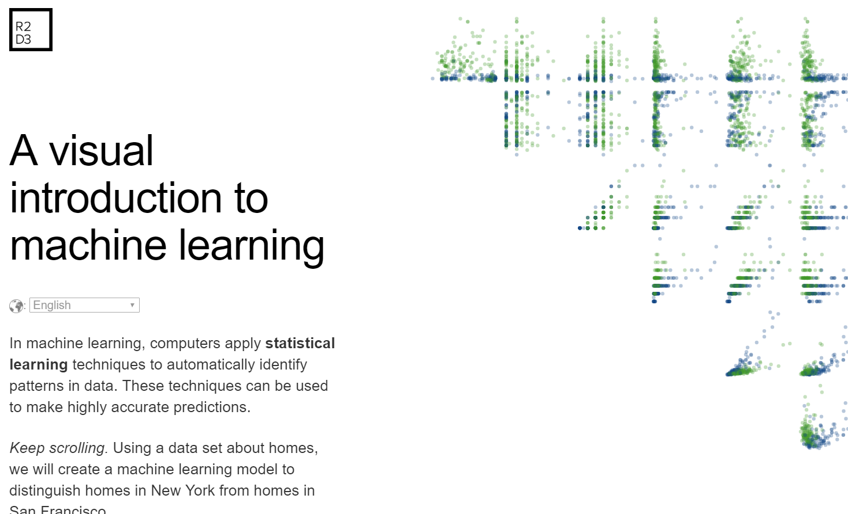

If you are up to it: this Notebook <https://www.kaggle.com/dmilla/introduction-to-decision-trees-titanic-dataset> describes the creation of a decision tree model for estimating the survival chance for passengers on the Titanic based on information we have on these passengers. The article is fairly technical – but the steps and conclusions are fairly easy to grasp. The final outcome is a decision tree, that can predict the fate of passengers with an 82% accuracy, using just five attributes (Fare, Family Size, Title (rather than Sex), Has_Cabin, PClass):

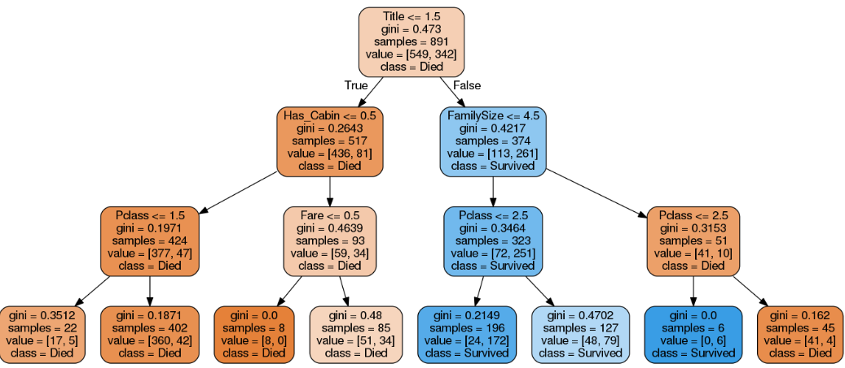

# More Fun Projects

Machine learning exists in many forms and flavors. As do demos. Here a collection of links to bite-size demos, ready to run in your browser.

## Reinforcement Learning Demo

One way to train an agent is through reinforcement: reward positive behavior and punish poor actions. Over time, the behavior of the trained ‘agent’ should become more effective.

An example of reinforcement learning is seen in this demo: <http://projects.rajivshah.com/rldemo/>

You can play with the parameters in order to influence the learning approach as well as the definition of good behavior.

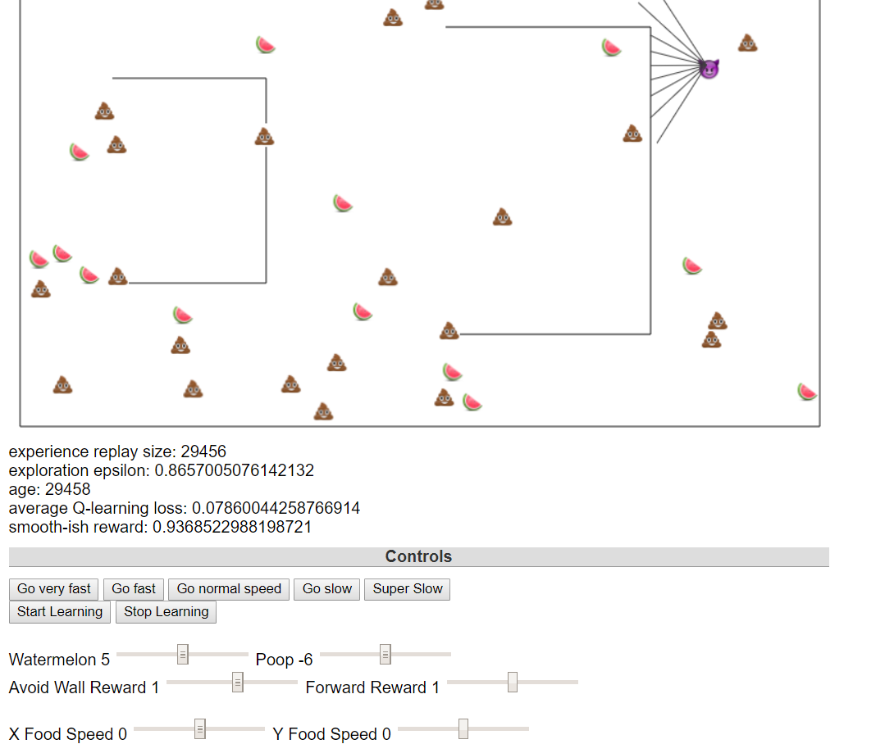

## Google AI Experiements

At <https://experiments.withgoogle.com/ai> you will find various experiments with Artificial Intelligence , including machine learning. If you have some time left, it might be fun to take a look around. One of the experiements is described below – the NSynth sound maker.

### NSynth – sound maker

This experiment lets you play with new sounds created with machine learning. It’s built using Nsynth, a research project that trained a neural network on over 300,000 instrument sounds. NSynth is able to combine sounds, like a bass and flute, into a new, hybrid bass-flute sound. This experiment lets anyone explore these sounds and make music with them: <https://experiments.withgoogle.com/ai/sound-maker> . It lets you merge different sounds and instruments – including a Flute and a Cat or a Dog and an Organ.

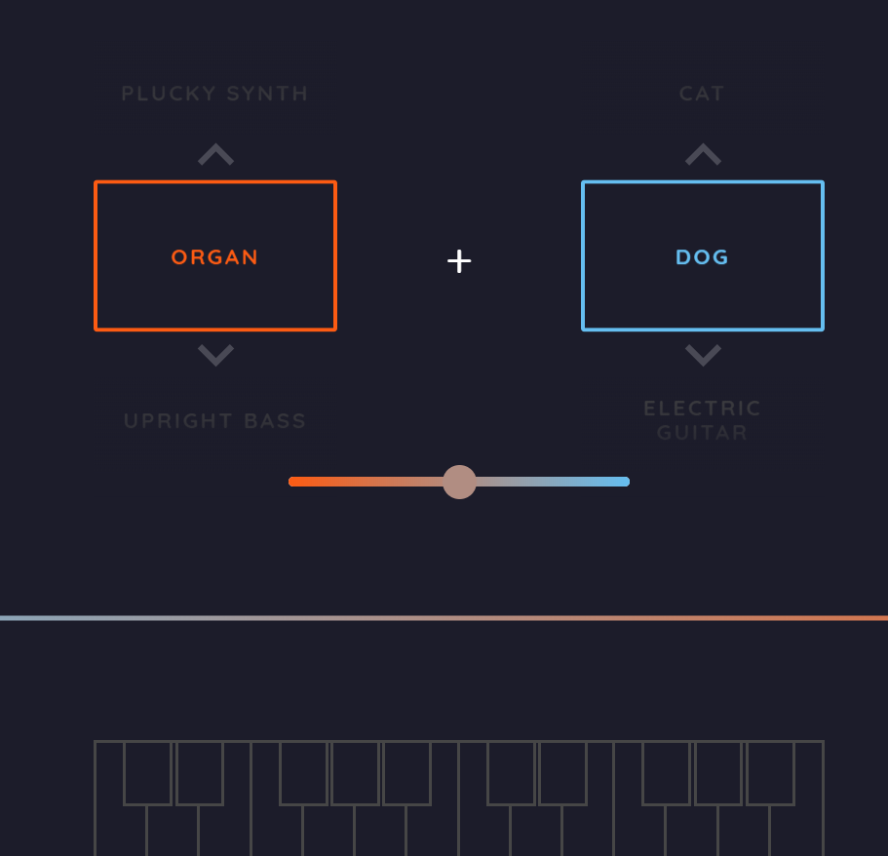

## Collection of Demonstrations for use by Teachers

This article provides a substantial collection of machine learning examples and demonstrations. Most of these are not online, ready to run, and many of them require some additional knowledge or mathematical skills. Be warned: <http://arogozhnikov.github.io/2016/04/28/demonstrations-for-ml-courses.html> .